[The Best Apps for Tinnitus | Curated by an Audiologist (tinnitusapps.com)](https://www.tinnitusapps.com/) Dr. Mandi Solat.

[[](https://www.tinnitusapps.com/tinnitus-apps/widex-zen)](https://www.tinnitusapps.com/tinnitus-apps/widex-zen)

**[Widex Zen](https://www.tinnitusapps.com/tinnitus-apps/widex-zen)**

**[DR. SOLAT FAVORITE](https://www.tinnitusapps.com/tinnitus-apps/widex-zen)**

[Widex is a top hearing aid manufacturer. Their Zen programs are specific to their brand. There is a timer that can be set for the tinnitus masker. Great feature: being able to adjust the left and right ear volume controls separately.](https://www.tinnitusapps.com/tinnitus-apps/widex-zen)

**[LEARN MORE](https://www.tinnitusapps.com/tinnitus-apps/widex-zen)**

[[](https://www.tinnitusapps.com/tinnitus-apps/starkey-relax)](https://www.tinnitusapps.com/tinnitus-apps/starkey-relax)

**[Starkey Relax](https://www.tinnitusapps.com/tinnitus-apps/starkey-relax)**

**[DR. SOLAT FAVORITE](https://www.tinnitusapps.com/tinnitus-apps/starkey-relax)**

[Starkey Relax allows you to customize 12 relief sounds by modifying the volume, frequency response, and rate of fluctuation, providing you with highly-personalized relief sounds for your unique tinnitus.](https://www.tinnitusapps.com/tinnitus-apps/starkey-relax)

**[LEARN MORE](https://www.tinnitusapps.com/tinnitus-apps/starkey-relax)**

[[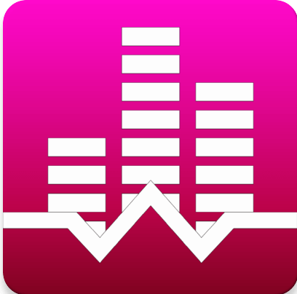](https://www.tinnitusapps.com/tinnitus-apps/white-noise-lite)](https://www.tinnitusapps.com/tinnitus-apps/white-noise-lite)

**[White Noise Lite](https://www.tinnitusapps.com/tinnitus-apps/white-noise-lite)**

**[DR. SOLAT FAVORITE](https://www.tinnitusapps.com/tinnitus-apps/white-noise-lite)**

[The White Noise Lite app offers 40+ perfectly looped sounds with free downloads. Its extremely easy to navigate and provides great sound quality. It also includes timers, alarms and a sleep clock.](https://www.tinnitusapps.com/tinnitus-apps/white-noise-lite)

**[LEARN MORE](https://www.tinnitusapps.com/tinnitus-apps/white-noise-lite)**

[[](https://www.tinnitusapps.com/tinnitus-apps/rain-rain-sleep-sounds-apps)](https://www.tinnitusapps.com/tinnitus-apps/rain-rain-sleep-sounds-apps)

**[Rain Rain Sleep Sounds Apps](https://www.tinnitusapps.com/tinnitus-apps/rain-rain-sleep-sounds-apps)**

**[DR. SOLAT FAVORITE](https://www.tinnitusapps.com/tinnitus-apps/rain-rain-sleep-sounds-apps)**

[The Rain Rain Sleep Sounds app offer lots and lots of nature sounds, thunder, rain, fire, etc. It's very easy to navigate and allows you to save your favorites for future use.](https://www.tinnitusapps.com/tinnitus-apps/rain-rain-sleep-sounds-apps)

**[LEARN MORE](https://www.tinnitusapps.com/tinnitus-apps/rain-rain-sleep-sounds-apps)**

[[](https://www.tinnitusapps.com/tinnitus-apps/chill-lite)](https://www.tinnitusapps.com/tinnitus-apps/chill-lite)

**[Chill Lite](https://www.tinnitusapps.com/tinnitus-apps/chill-lite)**

**[DR. SOLAT FAVORITE](https://www.tinnitusapps.com/tinnitus-apps/chill-lite)**

[The Chill Lite App let's you sleep, relax, and focus to soothing white noise sounds by Dave Cheng. The sound quality, and sound choices are good. There is a sleep timer. Easy to navigate.](https://www.tinnitusapps.com/tinnitus-apps/chill-lite)

**[LEARN MORE](https://www.tinnitusapps.com/tinnitus-apps/chill-lite)**

[[](https://www.tinnitusapps.com/tinnitus-apps/relax-meditation)](https://www.tinnitusapps.com/tinnitus-apps/relax-meditation)

**[Relax Meditation](https://www.tinnitusapps.com/tinnitus-apps/relax-meditation)**

**[DR. SOLAT FAVORITE](https://www.tinnitusapps.com/tinnitus-apps/relax-meditation)**

[This app offer a lot of relaxing sounds. It's easy to use, simply scroll through to find something to listen to. There are a lot of pop-up ads when picking a sound.](https://www.tinnitusapps.com/tinnitus-apps/relax-meditation)

**[LEARN MORE](https://www.tinnitusapps.com/tinnitus-apps/relax-meditation)**

[[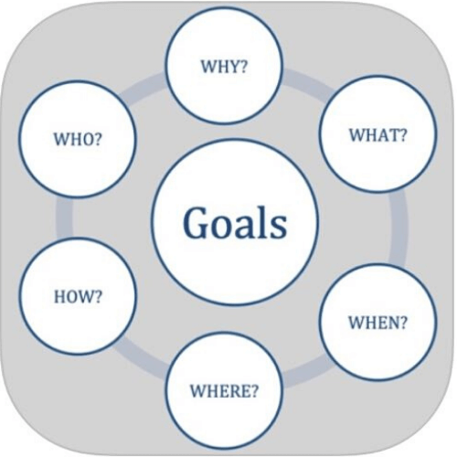](https://www.tinnitusapps.com/tinnitus-apps/my-practical-tinnitus)](https://www.tinnitusapps.com/tinnitus-apps/my-practical-tinnitus)

**[My Practical Tinnitus](https://www.tinnitusapps.com/tinnitus-apps/my-practical-tinnitus)**

**[DR. SOLAT FAVORITE](https://www.tinnitusapps.com/tinnitus-apps/my-practical-tinnitus)**

[A goal oriented practical tinnitus management app, for those where no other related etiology exists, based on published clinical guidelines, with free activities and guidance to help reduce tinnitus bother.](https://www.tinnitusapps.com/tinnitus-apps/my-practical-tinnitus)

**[LEARN MORE](https://www.tinnitusapps.com/tinnitus-apps/my-practical-tinnitus)**

[[](https://www.tinnitusapps.com/tinnitus-apps/ambient-mixer)](https://www.tinnitusapps.com/tinnitus-apps/ambient-mixer)

**[Ambient Mixer](https://www.tinnitusapps.com/tinnitus-apps/ambient-mixer)**

[Listen to relaxing music, ambient atmospheres and astonishing sound effects. If you want, you can even create your own atmospheric sound mix, online and for free. Every audio template can be easily edited for your own needs.](https://www.tinnitusapps.com/tinnitus-apps/ambient-mixer)

**[LEARN MORE](https://www.tinnitusapps.com/tinnitus-apps/ambient-mixer)**

[[](https://www.tinnitusapps.com/tinnitus-apps/oak-meditation-breathing)](https://www.tinnitusapps.com/tinnitus-apps/oak-meditation-breathing)

**[Oak - Meditation & Breathing](https://www.tinnitusapps.com/tinnitus-apps/oak-meditation-breathing)**

[Oak helps you decompress by transforming your meditation practice from an experiment into a habit. Oak tracks your progress and encourages you to continue building a healthy meditation practice.](https://www.tinnitusapps.com/tinnitus-apps/oak-meditation-breathing)

**[LEARN MORE](https://www.tinnitusapps.com/tinnitus-apps/oak-meditation-breathing)**

[[](https://www.tinnitusapps.com/tinnitus-apps/mindfulness-coach)](https://www.tinnitusapps.com/tinnitus-apps/mindfulness-coach)

**[Mindfulness Coach](https://www.tinnitusapps.com/tinnitus-apps/mindfulness-coach)**

[The app provides a gradual, self-guided training program designed to help you understand and adopt a simple mindfulness practice. Mindfulness Coach was created by VA’s National Center for PTSD.](https://www.tinnitusapps.com/tinnitus-apps/mindfulness-coach)

**[LEARN MORE](https://www.tinnitusapps.com/tinnitus-apps/mindfulness-coach)**

[[](https://www.tinnitusapps.com/tinnitus-apps/resound-relief-app)](https://www.tinnitusapps.com/tinnitus-apps/resound-relief-app)

**[The ReSound Relief App](https://www.tinnitusapps.com/tinnitus-apps/resound-relief-app)**

[Layer up to five different sounds and create a soundscape to ease your tinnitus. With your library of soundscapes, balance the sounds between your left and right ears and use a timer for a personalized and soothing experience.](https://www.tinnitusapps.com/tinnitus-apps/resound-relief-app)

**[LEARN MORE](https://www.tinnitusapps.com/tinnitus-apps/resound-relief-app)**

[[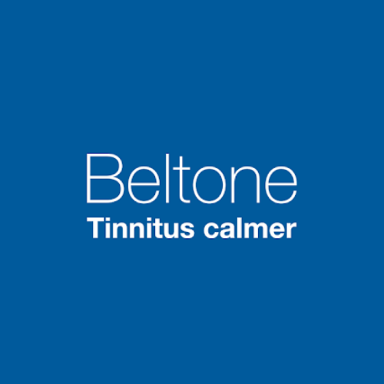](https://www.tinnitusapps.com/tinnitus-apps/beltone-calmer)](https://www.tinnitusapps.com/tinnitus-apps/beltone-calmer)

**[Beltone Calmer](https://www.tinnitusapps.com/tinnitus-apps/beltone-calmer)**

[Manage your tinnitus with the new Sound Therapy app. Distract your brain from focusing on your tinnitus with the help of Beltone's Tinnitus Calmer app. The app offers a combination of Sound Therapy and relaxing exercises which can help provide relief from tinnitus.](https://www.tinnitusapps.com/tinnitus-apps/beltone-calmer)

**[LEARN MORE](https://www.tinnitusapps.com/tinnitus-apps/beltone-calmer)**

[[](https://www.tinnitusapps.com/tinnitus-apps/tinnitus-therapy-lite)](https://www.tinnitusapps.com/tinnitus-apps/tinnitus-therapy-lite)

**[Tinnitus Therapy Lite](https://www.tinnitusapps.com/tinnitus-apps/tinnitus-therapy-lite)**

[This Lite version of the app provides a sample of just a few of their effective Tinnitus relief sounds, a fully functional playback timer, and soft off volume management.](https://www.tinnitusapps.com/tinnitus-apps/tinnitus-therapy-lite)

**[LEARN MORE](https://www.tinnitusapps.com/tinnitus-apps/tinnitus-therapy-lite)**

[[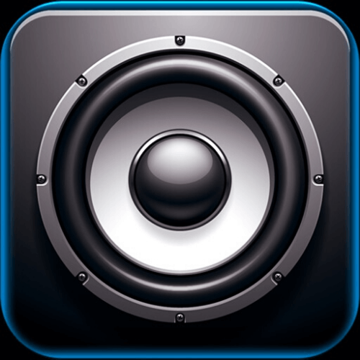](https://www.tinnitusapps.com/tinnitus-apps/just-noise-lite)](https://www.tinnitusapps.com/tinnitus-apps/just-noise-lite)

**[Just Noise Lite](https://www.tinnitusapps.com/tinnitus-apps/just-noise-lite)**

[This app offers adjustable white noise with 30 minutes for free. If you wan't longer, it's .99 cents for unlimited,. This offers a few more white noise choices, and the ability to preset your favorite settings.](https://www.tinnitusapps.com/tinnitus-apps/just-noise-lite)

**[LEARN MORE](https://www.tinnitusapps.com/tinnitus-apps/just-noise-lite)**

[[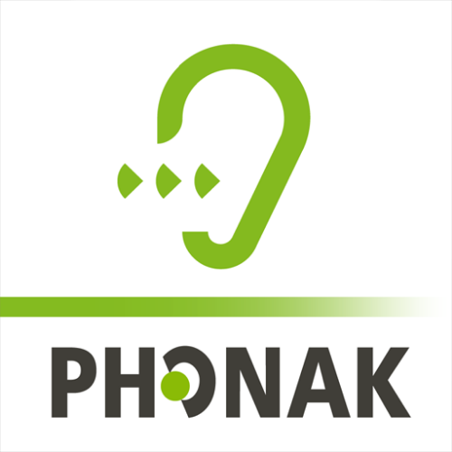](https://www.tinnitusapps.com/tinnitus-apps/tinnitus-balance)](https://www.tinnitusapps.com/tinnitus-apps/tinnitus-balance)

**[Tinnitus Balance](https://www.tinnitusapps.com/tinnitus-apps/tinnitus-balance)**

[Tinnitus balance by the hearing aid manufacturer Phonak. It is a bit confusing. You add sounds from their library if you can find it-and your own music selection.](https://www.tinnitusapps.com/tinnitus-apps/tinnitus-balance)

**[LEARN MORE](https://www.tinnitusapps.com/tinnitus-apps/tinnitus-balance)**

[[](https://www.tinnitusapps.com/tinnitus-apps/tinnitus-masking)](https://www.tinnitusapps.com/tinnitus-apps/tinnitus-masking)

**[Tinnitus & Masking](https://www.tinnitusapps.com/tinnitus-apps/tinnitus-masking)**

[Tinnitus & Masking by John Goodstadt. It offers one masking noise, with no other choices. Good for someone who doesn't need or desire any choices.](https://www.tinnitusapps.com/tinnitus-apps/tinnitus-masking)

**[LEARN MORE](https://www.tinnitusapps.com/tinnitus-apps/tinnitus-masking)**

[[](https://www.tinnitusapps.com/tinnitus-apps/white-noise-hq-sound-machine)](https://www.tinnitusapps.com/tinnitus-apps/white-noise-hq-sound-machine)

**[White Noise HQ: Sound Machine](https://www.tinnitusapps.com/tinnitus-apps/white-noise-hq-sound-machine)**

[Sounds and mixes. Not an overwhelming amount.](https://www.tinnitusapps.com/tinnitus-apps/white-noise-hq-sound-machine)

**[LEARN MORE](https://www.tinnitusapps.com/tinnitus-apps/white-noise-hq-sound-machine)**

[[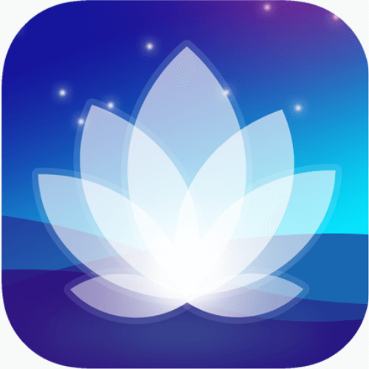](https://www.tinnitusapps.com/tinnitus-apps/taomix2)](https://www.tinnitusapps.com/tinnitus-apps/taomix2)

**[TaoMix2](https://www.tinnitusapps.com/tinnitus-apps/taomix2)**

[The sounds are good quality. The site is hard to navigate, and not user friendly.](https://www.tinnitusapps.com/tinnitus-apps/taomix2)

**[LEARN MORE](https://www.tinnitusapps.com/tinnitus-apps/taomix2)**

[[](https://www.tinnitusapps.com/tinnitus-apps/tinnitus-aid-help-ear-ringing)](https://www.tinnitusapps.com/tinnitus-apps/tinnitus-aid-help-ear-ringing)

**[Tinnitus Aid: Help Ear Ringing](https://www.tinnitusapps.com/tinnitus-apps/tinnitus-aid-help-ear-ringing)**

[Help Ear Ringing by Phase4Mobile. This app offers tinnitus masking mixes. The sounds are nice and it's somewhat user friendly, but not super easy to navigate.](https://www.tinnitusapps.com/tinnitus-apps/tinnitus-aid-help-ear-ringing)

**[LEARN MORE](https://www.tinnitusapps.com/tinnitus-apps/tinnitus-aid-help-ear-ringing)**

[[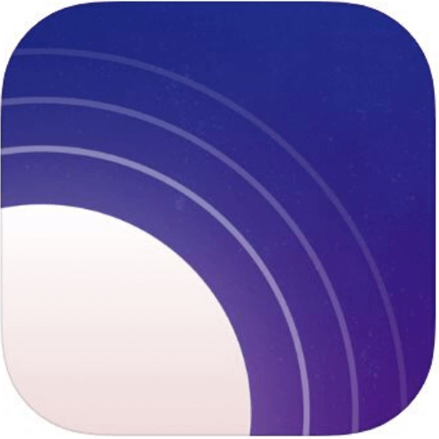](https://www.tinnitusapps.com/tinnitus-apps/noise-machine-white-noise)](https://www.tinnitusapps.com/tinnitus-apps/noise-machine-white-noise)

**[Noise Machine-White Noise](https://www.tinnitusapps.com/tinnitus-apps/noise-machine-white-noise)**

[Fall asleep easily, focus, or relax with Noise Machine – a calming white noise generator.](https://www.tinnitusapps.com/tinnitus-apps/noise-machine-white-noise)

**[LEARN MORE](https://www.tinnitusapps.com/tinnitus-apps/noise-machine-white-noise)**

[[](https://www.tinnitusapps.com/tinnitus-apps/ambient-sounds)](https://www.tinnitusapps.com/tinnitus-apps/ambient-sounds)

**[Ambient Sounds](https://www.tinnitusapps.com/tinnitus-apps/ambient-sounds)**

[Ambience offers a wide range of high quality sounds, for you to visit calm, vibrant or remote places within a second, for as long as you choose.](https://www.tinnitusapps.com/tinnitus-apps/ambient-sounds)

**[LEARN MORE](https://www.tinnitusapps.com/tinnitus-apps/ambient-sounds)**

[[](https://www.tinnitusapps.com/tinnitus-apps/deep-sleep-3d-nature-sounds)](https://www.tinnitusapps.com/tinnitus-apps/deep-sleep-3d-nature-sounds)

**[Deep Sleep 3D Nature Sounds](https://www.tinnitusapps.com/tinnitus-apps/deep-sleep-3d-nature-sounds)**

[Good sound selection. Easy to navigate. Multiple sounds mixes with volume control adjustment for each separate mix. Do not click on Pro version if you don't want to spend $. A lot of ads.](https://www.tinnitusapps.com/tinnitus-apps/deep-sleep-3d-nature-sounds)

**[LEARN MORE](https://www.tinnitusapps.com/tinnitus-apps/deep-sleep-3d-nature-sounds)**

[[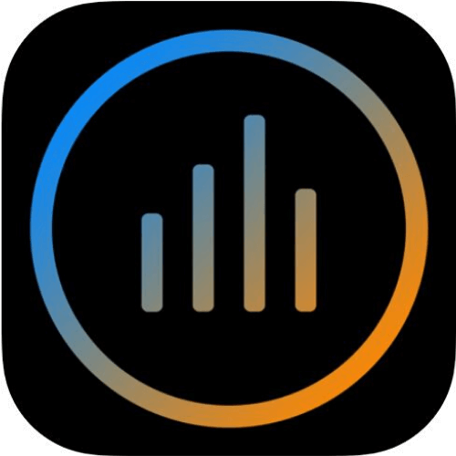](https://www.tinnitusapps.com/tinnitus-apps/mynoise)](https://www.tinnitusapps.com/tinnitus-apps/mynoise)

**[myNoise](https://www.tinnitusapps.com/tinnitus-apps/mynoise)**

[The Ultimate Background Noise App Small selection of free sounds, but very nice. Ability to increase bass/mid/treble. Easy to navigate.](https://www.tinnitusapps.com/tinnitus-apps/mynoise)

**[LEARN MORE](https://www.tinnitusapps.com/tinnitus-apps/mynoise)**

[[](https://www.tinnitusapps.com/tinnitus-apps/relax-noise-3)](https://www.tinnitusapps.com/tinnitus-apps/relax-noise-3)

**[Relax Noise 3](https://www.tinnitusapps.com/tinnitus-apps/relax-noise-3)**

[Relax Noise 3 masks nerving ambient noise and also your tinnitus with white, pink or red background noise. All three noise signals are random signals but with different acoustic colors.](https://www.tinnitusapps.com/tinnitus-apps/relax-noise-3)

**[LEARN MORE](https://www.tinnitusapps.com/tinnitus-apps/relax-noise-3)**

[[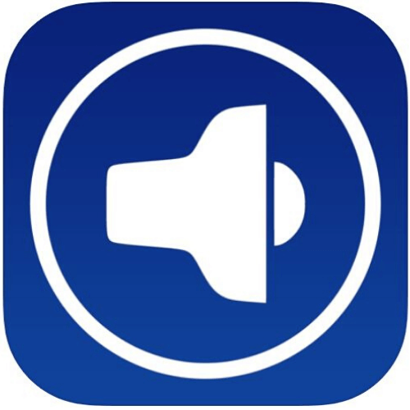](https://www.tinnitusapps.com/tinnitus-apps/simple-free-white-noise)](https://www.tinnitusapps.com/tinnitus-apps/simple-free-white-noise)

**[Simple Free White Noise](https://www.tinnitusapps.com/tinnitus-apps/simple-free-white-noise)**

[SimplyNoise’s signature color noises are utilized in clinics, schools, and workplaces around the world to help people of all age groups and professions focus, relax, and sleep better.](https://www.tinnitusapps.com/tinnitus-apps/simple-free-white-noise)

**[LEARN MORE](https://www.tinnitusapps.com/tinnitus-apps/simple-free-white-noise)**

HELP FOR RINGING EARS

**The Best Paid Tinnitus Apps**

[[](https://www.tinnitusapps.com/tinnitus-apps/noizio)](https://www.tinnitusapps.com/tinnitus-apps/noizio)

**[DR. SOLAT FAVORITE](https://www.tinnitusapps.com/tinnitus-apps/noizio)**

**[Noizio](https://www.tinnitusapps.com/tinnitus-apps/noizio)**

[$](https://www.tinnitusapps.com/tinnitus-apps/noizio)

[2.99](https://www.tinnitusapps.com/tinnitus-apps/noizio)

[Noizio offfers great sound choices. It's very easy to navigate and adjust the volume.The app includes a timer and it can mix multiple sounds.](https://www.tinnitusapps.com/tinnitus-apps/noizio)

**[LEARN MORE](https://www.tinnitusapps.com/tinnitus-apps/noizio)**

[[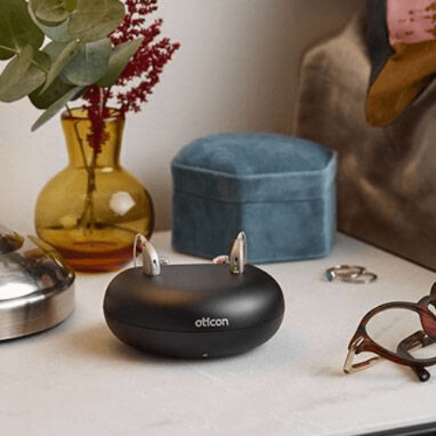](https://www.tinnitusapps.com/tinnitus-apps/oticon-opn-s-tinnitus-rechargeable-hearing-aid)](https://www.tinnitusapps.com/tinnitus-apps/oticon-opn-s-tinnitus-rechargeable-hearing-aid)

**[DR. SOLAT FAVORITE](https://www.tinnitusapps.com/tinnitus-apps/oticon-opn-s-tinnitus-rechargeable-hearing-aid)**

**[Oticon OPN S Tinnitus Rechargeable Hearing Aid](https://www.tinnitusapps.com/tinnitus-apps/oticon-opn-s-tinnitus-rechargeable-hearing-aid)**

[With the help of your audiologist, get a tinnitus sound masker in your hearing aid or listen to an tinnitus application through your device.](https://www.tinnitusapps.com/tinnitus-apps/oticon-opn-s-tinnitus-rechargeable-hearing-aid)

**[LEARN MORE](https://www.tinnitusapps.com/tinnitus-apps/oticon-opn-s-tinnitus-rechargeable-hearing-aid)**

[[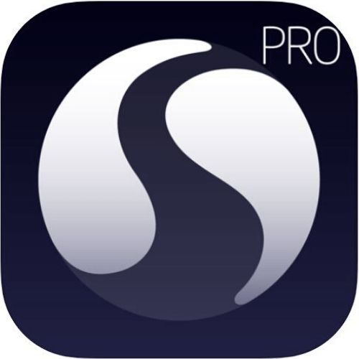](https://www.tinnitusapps.com/tinnitus-apps/sleepstream-2-pro)](https://www.tinnitusapps.com/tinnitus-apps/sleepstream-2-pro)

**[DR. SOLAT FAVORITE](https://www.tinnitusapps.com/tinnitus-apps/sleepstream-2-pro)**

**[SleepStream 2 Pro](https://www.tinnitusapps.com/tinnitus-apps/sleepstream-2-pro)**

[$](https://www.tinnitusapps.com/tinnitus-apps/sleepstream-2-pro)

[2.99](https://www.tinnitusapps.com/tinnitus-apps/sleepstream-2-pro)

[Premium tinnitus sound therapy. Easy to use Multiple overlays with many different tinnitus sounds. Great quality sound, easy to use, and lots of choices.](https://www.tinnitusapps.com/tinnitus-apps/sleepstream-2-pro)

**[LEARN MORE](https://www.tinnitusapps.com/tinnitus-apps/sleepstream-2-pro)**

[[](https://www.tinnitusapps.com/tinnitus-apps/mindfulness-based-tinnitus-based-stress-reduction)](https://www.tinnitusapps.com/tinnitus-apps/mindfulness-based-tinnitus-based-stress-reduction)

**[DR. SOLAT FAVORITE](https://www.tinnitusapps.com/tinnitus-apps/mindfulness-based-tinnitus-based-stress-reduction)**

**[Mindfulness Based Tinnitus Based Stress Reduction](https://www.tinnitusapps.com/tinnitus-apps/mindfulness-based-tinnitus-based-stress-reduction)**

[$](https://www.tinnitusapps.com/tinnitus-apps/mindfulness-based-tinnitus-based-stress-reduction)

[325](https://www.tinnitusapps.com/tinnitus-apps/mindfulness-based-tinnitus-based-stress-reduction)

[Dr. Jennifer Gans. 8-week skill building program focusing on reframing a person's experience with bothersome tinnitus symptoms. Excellent course for those who want structure, and a deep understanding of their tinnitus.](https://www.tinnitusapps.com/tinnitus-apps/mindfulness-based-tinnitus-based-stress-reduction)

**[LEARN MORE](https://www.tinnitusapps.com/tinnitus-apps/mindfulness-based-tinnitus-based-stress-reduction)**

[[](https://www.tinnitusapps.com/tinnitus-apps/relax-melodies)](https://www.tinnitusapps.com/tinnitus-apps/relax-melodies)

**[DR. SOLAT FAVORITE](https://www.tinnitusapps.com/tinnitus-apps/relax-melodies)**

**[Relax Melodies](https://www.tinnitusapps.com/tinnitus-apps/relax-melodies)**

[$](https://www.tinnitusapps.com/tinnitus-apps/relax-melodies)

[59.99](https://www.tinnitusapps.com/tinnitus-apps/relax-melodies)

[Get ready to sleep. Nice app. $59.99/year. Easy to navigate. Sleep meditations. Lots of choices.](https://www.tinnitusapps.com/tinnitus-apps/relax-melodies)

**[LEARN MORE](https://www.tinnitusapps.com/tinnitus-apps/relax-melodies)**

[[](https://www.tinnitusapps.com/tinnitus-apps/t-minus-tinnitus-wellness)](https://www.tinnitusapps.com/tinnitus-apps/t-minus-tinnitus-wellness)

**[T-Minus - Tinnitus Wellness](https://www.tinnitusapps.com/tinnitus-apps/t-minus-tinnitus-wellness)**

[$](https://www.tinnitusapps.com/tinnitus-apps/t-minus-tinnitus-wellness)

[4.99/MO](https://www.tinnitusapps.com/tinnitus-apps/t-minus-tinnitus-wellness)

[Perfect for anyone experiencing the symptoms of tinnitus, T-Minus is brought to you with the help of Audiologists, Hearing Therapists, ENT consultants and other health experts.](https://www.tinnitusapps.com/tinnitus-apps/t-minus-tinnitus-wellness)

**[LEARN MORE](https://www.tinnitusapps.com/tinnitus-apps/t-minus-tinnitus-wellness)**

[[](https://www.tinnitusapps.com/tinnitus-apps/buddhify)](https://www.tinnitusapps.com/tinnitus-apps/buddhify)

**[Buddhify](https://www.tinnitusapps.com/tinnitus-apps/buddhify)**

[$](https://www.tinnitusapps.com/tinnitus-apps/buddhify)

[4.99/MO](https://www.tinnitusapps.com/tinnitus-apps/buddhify)

[Whether you're looking to reduce stress and anxiety, or get a better night's sleep buddhify has easy-to-follow guided meditations to help you live happier and healthier.](https://www.tinnitusapps.com/tinnitus-apps/buddhify)

**[LEARN MORE](https://www.tinnitusapps.com/tinnitus-apps/buddhify)**

[[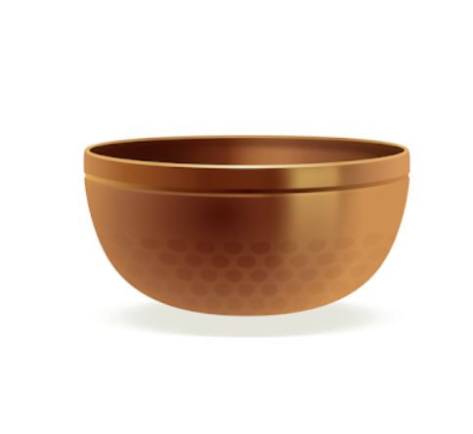](https://www.tinnitusapps.com/tinnitus-apps/insight-timer-meditation-sleep-music)](https://www.tinnitusapps.com/tinnitus-apps/insight-timer-meditation-sleep-music)

**[Insight Timer - Meditation, Sleep, Music](https://www.tinnitusapps.com/tinnitus-apps/insight-timer-meditation-sleep-music)**

[$](https://www.tinnitusapps.com/tinnitus-apps/insight-timer-meditation-sleep-music)

[9.99/MO](https://www.tinnitusapps.com/tinnitus-apps/insight-timer-meditation-sleep-music)

[Join millions learning to meditate on Insight Timer to help calm the mind, reduce anxiety, manage stress, sleep deeply and improve happiness.](https://www.tinnitusapps.com/tinnitus-apps/insight-timer-meditation-sleep-music)

**[LEARN MORE](https://www.tinnitusapps.com/tinnitus-apps/insight-timer-meditation-sleep-music)**

[[](https://www.tinnitusapps.com/tinnitus-apps/ten-percent-happier)](https://www.tinnitusapps.com/tinnitus-apps/ten-percent-happier)

**[Ten Percent Happier](https://www.tinnitusapps.com/tinnitus-apps/ten-percent-happier)**

[$](https://www.tinnitusapps.com/tinnitus-apps/ten-percent-happier)

[9.99/MO](https://www.tinnitusapps.com/tinnitus-apps/ten-percent-happier)

[Want to sleep better, be more mindful, improve your relationships, and become just about ten percent happier? This is the app for you. Our guided meditations, videos, talks, and sleep content will help you build (or boost) your meditation practice, and stick with it.](https://www.tinnitusapps.com/tinnitus-apps/ten-percent-happier)

**[LEARN MORE](https://www.tinnitusapps.com/tinnitus-apps/ten-percent-happier)**

[[](https://www.tinnitusapps.com/tinnitus-apps/tinnitus-help)](https://www.tinnitusapps.com/tinnitus-apps/tinnitus-help)

**[Tinnitus Help](https://www.tinnitusapps.com/tinnitus-apps/tinnitus-help)**

[$](https://www.tinnitusapps.com/tinnitus-apps/tinnitus-help)

[15.99](https://www.tinnitusapps.com/tinnitus-apps/tinnitus-help)

[Programming your own frequency, vibrations, and tempo for tinnitus noise. Then, mix the tinnitus noise with an additional pleasing sound. This starts the process of masking your tinnitus.](https://www.tinnitusapps.com/tinnitus-apps/tinnitus-help)

**[LEARN MORE](https://www.tinnitusapps.com/tinnitus-apps/tinnitus-help)**

[[](https://www.tinnitusapps.com/tinnitus-apps/whist)](https://www.tinnitusapps.com/tinnitus-apps/whist)

**[Whist](https://www.tinnitusapps.com/tinnitus-apps/whist)**

[$](https://www.tinnitusapps.com/tinnitus-apps/whist)

[1.99](https://www.tinnitusapps.com/tinnitus-apps/whist)

[This application tries to match the pitch and loudness of your tinnitus in each ear to create a masking noise. Caution: this is for mild to moderate hearing losses only, and very basic.](https://www.tinnitusapps.com/tinnitus-apps/whist)

**[LEARN MORE](https://www.tinnitusapps.com/tinnitus-apps/whist)**

[[](https://www.tinnitusapps.com/tinnitus-apps/tinnitus-hq-ear-ringing-relief)](https://www.tinnitusapps.com/tinnitus-apps/tinnitus-hq-ear-ringing-relief)

**[Tinnitus HQ-ear ringing relief](https://www.tinnitusapps.com/tinnitus-apps/tinnitus-hq-ear-ringing-relief)**

[$](https://www.tinnitusapps.com/tinnitus-apps/tinnitus-hq-ear-ringing-relief)

[12.99](https://www.tinnitusapps.com/tinnitus-apps/tinnitus-hq-ear-ringing-relief)

[Recent research shows that tinnitus can be treated by listening to sounds that have been filtered to remove your specific tinnitus frequencies. With Tinnitus HQ, you can apply advanced filters to over 500 high-quality sounds to find relief for your symptoms.](https://www.tinnitusapps.com/tinnitus-apps/tinnitus-hq-ear-ringing-relief)

**[LEARN MORE](https://www.tinnitusapps.com/tinnitus-apps/tinnitus-hq-ear-ringing-relief)**

[[](https://www.tinnitusapps.com/tinnitus-apps/sleep-mask)](https://www.tinnitusapps.com/tinnitus-apps/sleep-mask)

**[Sleep Mask](https://www.tinnitusapps.com/tinnitus-apps/sleep-mask)**

[$](https://www.tinnitusapps.com/tinnitus-apps/sleep-mask)

[2.99](https://www.tinnitusapps.com/tinnitus-apps/sleep-mask)

[White noise for sleep, relaxation, and concentration. The free version is limited to pink, white, and brown noise. There is a $2.99 charge for extra features. which seem very limited.](https://www.tinnitusapps.com/tinnitus-apps/sleep-mask)

**[LEARN MORE](https://www.tinnitusapps.com/tinnitus-apps/sleep-mask)**

[[](https://www.tinnitusapps.com/tinnitus-apps/tinnitus-therapy-pro)](https://www.tinnitusapps.com/tinnitus-apps/tinnitus-therapy-pro)

**[Tinnitus Therapy Pro](https://www.tinnitusapps.com/tinnitus-apps/tinnitus-therapy-pro)**

[$](https://www.tinnitusapps.com/tinnitus-apps/tinnitus-therapy-pro)

[5.99](https://www.tinnitusapps.com/tinnitus-apps/tinnitus-therapy-pro)

[White noise, lots of good quality sounds. Easy to use. Equalizer. Timer. Some are simply great nature sounds. Others are different forms and frequencies of white noise.](https://www.tinnitusapps.com/tinnitus-apps/tinnitus-therapy-pro)

**[LEARN MORE](https://www.tinnitusapps.com/tinnitus-apps/tinnitus-therapy-pro)**

[[](https://www.tinnitusapps.com/tinnitus-apps/sleep-pillow-white-noise-sound)](https://www.tinnitusapps.com/tinnitus-apps/sleep-pillow-white-noise-sound)

**[Sleep Pillow White Noise Sound](https://www.tinnitusapps.com/tinnitus-apps/sleep-pillow-white-noise-sound)**

[$](https://www.tinnitusapps.com/tinnitus-apps/sleep-pillow-white-noise-sound)

[2.99](https://www.tinnitusapps.com/tinnitus-apps/sleep-pillow-white-noise-sound)

[Lots of sounds, and extremely easy to navigate. The sounds are recorded and enhanced to relax and make you sleep. They isolate, create a relaxed environment, and put you into a cyclical sleep pattern.](https://www.tinnitusapps.com/tinnitus-apps/sleep-pillow-white-noise-sound)

**[LEARN MORE](https://www.tinnitusapps.com/tinnitus-apps/sleep-pillow-white-noise-sound)**

[[](https://www.tinnitusapps.com/tinnitus-apps/tinnitus-relief-by-helena-lowen-aberg)](https://www.tinnitusapps.com/tinnitus-apps/tinnitus-relief-by-helena-lowen-aberg)

**[Tinnitus Relief by Helena Löwen-Åberg](https://www.tinnitusapps.com/tinnitus-apps/tinnitus-relief-by-helena-lowen-aberg)**

[$](https://www.tinnitusapps.com/tinnitus-apps/tinnitus-relief-by-helena-lowen-aberg)

[2.99](https://www.tinnitusapps.com/tinnitus-apps/tinnitus-relief-by-helena-lowen-aberg)

[A physiotherapist teaching relaxation and stress management with a cognitive approach. The application introduces short relaxation, body scan, and sleep well exercises.](https://www.tinnitusapps.com/tinnitus-apps/tinnitus-relief-by-helena-lowen-aberg)

**[LEARN MORE](https://www.tinnitusapps.com/tinnitus-apps/tinnitus-relief-by-helena-lowen-aberg)**

[[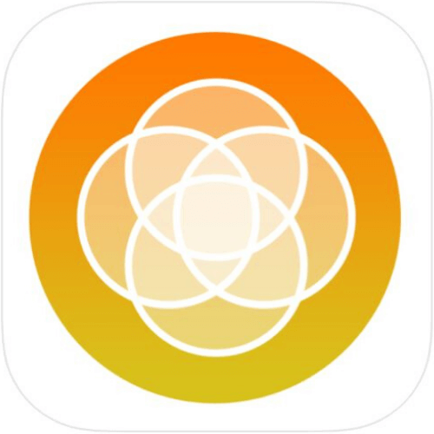](https://www.tinnitusapps.com/tinnitus-apps/enlighten)](https://www.tinnitusapps.com/tinnitus-apps/enlighten)

**[Enlighten](https://www.tinnitusapps.com/tinnitus-apps/enlighten)**

[$](https://www.tinnitusapps.com/tinnitus-apps/enlighten)

[0.99](https://www.tinnitusapps.com/tinnitus-apps/enlighten)

[Relax, meditate, and calm your mind by Prithiv Dev Devendran. Easy to navigate, difficult to figure out how to turn on the rain, fire, etc sounds. Just bells.](https://www.tinnitusapps.com/tinnitus-apps/enlighten)

**[LEARN MORE](https://www.tinnitusapps.com/tinnitus-apps/enlighten)**

[[](https://www.tinnitusapps.com/tinnitus-apps/discover-calm)](https://www.tinnitusapps.com/tinnitus-apps/discover-calm)

**[Calm](https://www.tinnitusapps.com/tinnitus-apps/discover-calm)**

[$](https://www.tinnitusapps.com/tinnitus-apps/discover-calm)

[5.83](https://www.tinnitusapps.com/tinnitus-apps/discover-calm)

[[Currently offering 40% off] Meditation and Sleep Free trial. $5.83/month $69.99/year. Mostly lovely meditations for better sleep, reducing anxiety, stress...No white noise. Relaxing music.](https://www.tinnitusapps.com/tinnitus-apps/discover-calm)

**[LEARN MORE](https://www.tinnitusapps.com/tinnitus-apps/discover-calm)**

[[](https://www.tinnitusapps.com/tinnitus-apps/tinnitus-alleviator-by-neuromonics)](https://www.tinnitusapps.com/tinnitus-apps/tinnitus-alleviator-by-neuromonics)

**[Tinnitus Alleviator by Neuromonics](https://www.tinnitusapps.com/tinnitus-apps/tinnitus-alleviator-by-neuromonics)**

[$](https://www.tinnitusapps.com/tinnitus-apps/tinnitus-alleviator-by-neuromonics)

[$$$ COSTLY](https://www.tinnitusapps.com/tinnitus-apps/tinnitus-alleviator-by-neuromonics)

[Neuromonics tinnitus treatment system is a customized music therapy system for the treatment of tinnitus.](https://www.tinnitusapps.com/tinnitus-apps/tinnitus-alleviator-by-neuromonics)

**[LEARN MORE](https://www.tinnitusapps.com/tinnitus-apps/tinnitus-alleviator-by-neuromonics)**

[[](https://www.tinnitusapps.com/tinnitus-apps/headspace)](https://www.tinnitusapps.com/tinnitus-apps/headspace)

**[HeadSpace](https://www.tinnitusapps.com/tinnitus-apps/headspace)**

[$](https://www.tinnitusapps.com/tinnitus-apps/headspace)

[12.99/MO](https://www.tinnitusapps.com/tinnitus-apps/headspace)

[Headspace is here to give you the tools and resources to look after your mind. And now, more than ever, it’s time to support those who really need it. If you’re unemployed, you can get a free year of Headspace Plus to help you get back on your feet](https://www.tinnitusapps.com/tinnitus-apps/headspace)